**Mitu Singha**

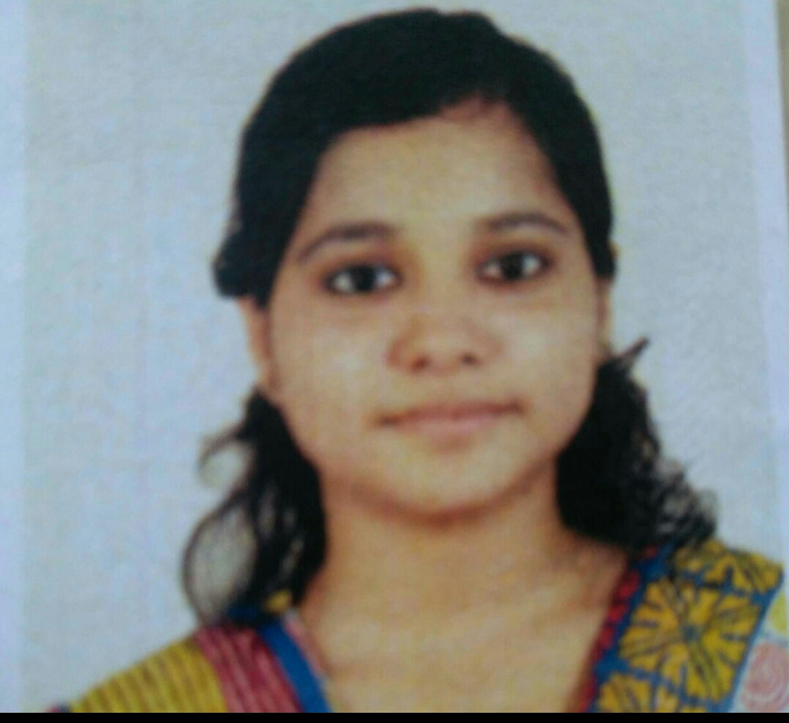

**Information Technology Student**

**OBJECTIVE**

I want to give my 100% effort in my work to gain knowledge by working in a team with experienced people.

**EDUCATION:-**

* **Class 10th (Secondery Examination)2014**

**89%**

Central Modern School

* **Class 12th (Higher Secondery Examination) 2016**

**76.80%**

**Stream: Science**

Central Modern School

* **Bachelor of Technology 2016-2020**

**CGPA: 7.93(up to 5th semester)**

**Stream: Information Technology**

JIS College of Engineering, Kalyani

**PERSONAL INFO**

* **Date of Birth**

21.07.1998

* **Address**

14,Swami Vivekananda Road, Barasat, kol-700124

* **Contact No.**

8621071620, 8620993996

* **Email**

Singha89mitu@gmail.com

* **Languages**

Bengali, English, Hindi

* **SUBJECTS OF INTEREST**

Operating System, Software Engineering

**SKILLS:-**

* Problem solving
* Project Management
* Leadership Capability
* Good Communication skills
* Public Speaking Skills
* Presentation Management
* **Programming Languages:-**
  + C, Java, HTML, CSS
* **Tools, Frameworks and libraries:-**
  + Data Structure

* **Databases:-**
  + MySql, MongoDb

**PROJECTS:-**

* **Web Development project:-**
  + Bogo- The Social Network App For JISCIANS(MERN Technology):- <https://limitless-shelf-17949.herokuapp.com/>

**ACHIEVEMENTS:-**

* Successfully Completed QEEE certification Course on Data Structure
* Successfully completed NPTEL certification Course on Data Structure with C

**DECLARATION:-**

I hereby **declare** that above particulars of information and facts stated are true, correct and complete to the best of my knowledge and belief.

Date:- …………………………………….

Signature